
R&D Exeter Mathematics School
Analysis of oceanographic timeseries

Background
Data of the marine environment such as temperature, salinity, turbidity and oxygen levels are useful for a wide variety of applications such as
- evidence used for water quality assessments
- improved understanding of environmental variability
- confirming satellite imagery of the sea ("ground truthing").
- improved model validation and testing
One means of collecting this data are autonomous moorings, or ‘Smartbuoys’, which collect multiple parameters at high temporal frequency.
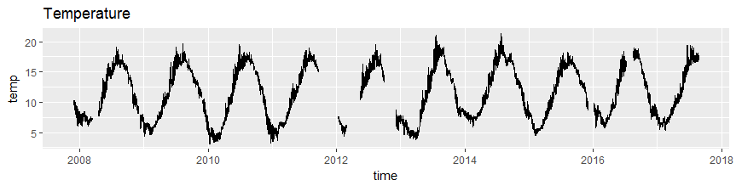

Aims and Objectives
- Interpolating gaps in the data
- Identify and remove errors
- Extracting trends

Data
Approximately 10 years of oceanographic data for a single location. Multiple parameters will be supplied.
- Temperature
- Salinity
- Turbidity – A measure of how clear the water is
- Chlorophyll fluorescence – How much Chlorophyll is present in the water
- Photosyntheic Available Radiation – the amount of light available for photosynthesis
- Oxygen level

Output
One or more of the following
- A methodology for cleaning the oceanographic time series. Separating real signal from errors and noise.
- A means of filling the gaps in the time series with associated measures of uncertainty.
- You may want to consider the physical processes which are underlying the data and build a model to simulate what is being seen.

Reviewers

Name | Role | Date reviewed | Version reviewed

